# Deep Learning

Lab – 6

Name: Yadukrishnan

Reg. No: 21BAI1210

Link to all the codes given below: [Github](https://github.com/yadu-tv/deep-learning-lab/tree/main/lab_6)

1. Tensorflow Transfer Learning

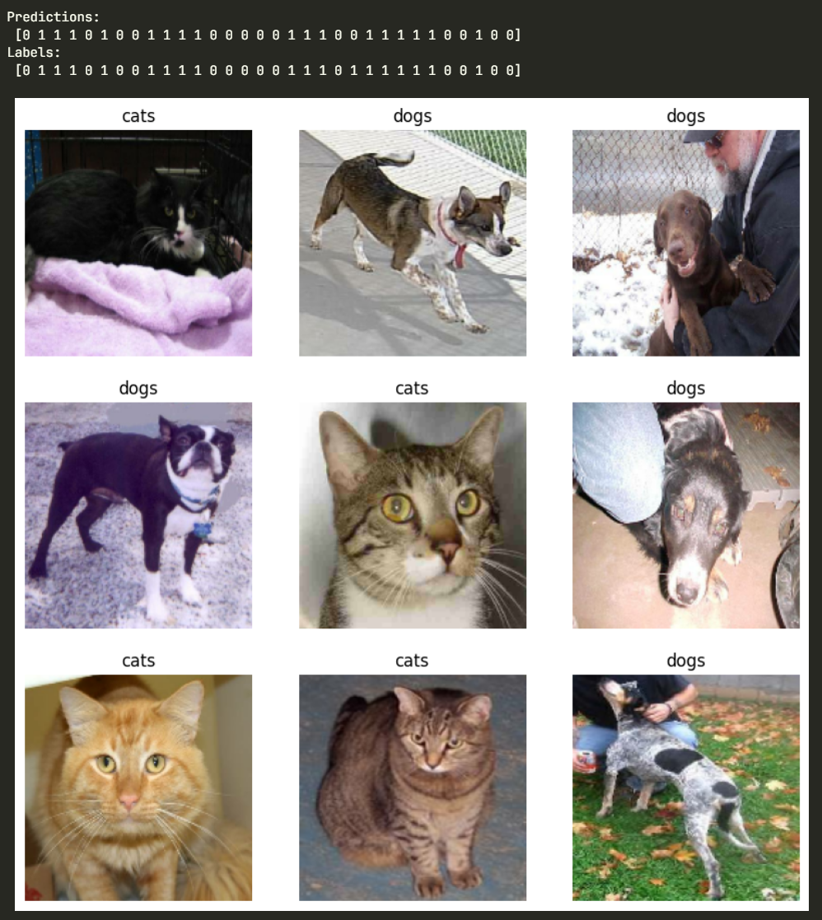

1. PyTorch Transfer Learning

1. Transfer Learning of VGG16, ResNet 50 and ResNet 152 using Tensorflow

